MONGODB

CLASS 2: ADD , UPDATE , AND DELETE

**Few Commands to test after connections**

**1.show dbs**

Absolutely, here's how you can list databases in MongoDB using the show dbs command along with an example:

**Connecting to MongoDB Shell:**

1. Make sure you have MongoDB installed and running.
2. Open your terminal or command prompt.
3. Type mongo and press enter to connect to the MongoDB shell. This will connect to the local MongoDB instance by default (usually on port 27017).

**Listing Databases:**

1. Once connected, type show dbs and press enter.

**Example:**

mongo

show dbs

This will display a list of all databases available on the MongoDB server. The output might look something like this:

local 0.0GB

admin 0.0GB

config 0.0GB

<your_database_name> 0.0GB

... (other databases)

**Explanation:**

* local: This is a special internal database used by MongoDB itself.
* admin: This database stores administrative data for MongoDB.
* config: This database stores configuration data for a deployment with multiple MongoDB instances (replica set or sharded cluster).
* <your_database_name>: This represents the names of your custom databases where you store your application data.
* The size (e.g., 0.0GB) indicates the approximate disk space used by the database.

**2.use db**

The use db command in MongoDB is used to switch between databases. Here's how it works with an example:

**Scenario:**

Imagine you have two databases: users and products. You want to work with the products database.

**Using use db:**

1. Connect to the MongoDB shell using mongo.
2. By default, you'll be in the admin database. To switch to the products database, type:

use products

**Example:**

mongo

use products

**Explanation:**

* The use products command tells MongoDB to start using the products database for subsequent operations (inserting/finding documents etc.).

**Verifying the Active Database:**

* To confirm the currently selected database, you can use the db command without any arguments:

db

This will print the name of the active database. In our example, it should display products.

**3.show collections**

In MongoDB, you can list the collections within a specific database using the show collections command. Here's how it works with an example:

**Steps:**

1. **Switch to the target database:** Use the use <database_name> command to select the database that contains the collections you want to list. Replace <database_name> with the actual name of your database.
2. **List collections:** Once you're in the desired database, type show collections and press enter.

**Example:**

Let's say you have a database named my_store with collections for customers and orders. Here's how to list them:

mongo

use my_store

show collections

This might output something like:

customers 0.0GB

orders 0.0GB

**Explanation:**

* The command lists the collection names (customers and orders) along with their approximate sizes (0.0GB in this case)

**4.** **db.foo.insert({"bar" : "baz"})**

The code db.foo.insert({"bar" : "baz"}) in MongoDB inserts a new document into a collection named "foo".

**Example:**

Assuming you're connected to MongoDB and have a database named "my_app" selected (using use my_app), this code would insert a new document into the "foo" collection within that database:

db.foo.insert({"bar" : "baz"})

This would create a document like this in the "foo" collection:

{

"_id" : ObjectId("..."), // MongoDB-generated unique identifier for the document

"bar" : "baz"

}

**5.db.foo.batchInsert([{"_id" : 0}, {"_id" : 1}, {"_id" : 2}])**

The code db.foo.batchInsert([{"_id" : 0}, {"_id" : 1}, {"_id" : 2}]) in MongoDB attempts to insert multiple documents into a collection using batch insertion, but there's a caveat.

There are two common approaches to achieve batch insertion in MongoDB:

**1. Using insert with an Array:**

The correct way to insert multiple documents at once is to use the insert method with an array of document objects:

db.foo.insert([

{"_id" : 0}, {"_id" : 1}, {"_id" : 2}

])

This will insert three documents into the "foo" collection, each with the specified _id field.

**2. Using insertMany (Preferred):**

MongoDB provides a dedicated method called insertMany for bulk insertion. It's generally preferred over using insert with an array because insertMany offers more options and better performance for larger datasets:

db.foo.insertMany([

{"_id" : 0}, {"_id" : 1}, {"_id" : 2}

])

This achieves the same result as the previous approach but leverages the optimized insertMany method.

**6.  db.foo.find()**

The command db.foo.find() in MongoDB is used to search for documents in a collection named "foo" within the currently active database.

**Example:**

Assuming you have a collection named "foo" with various documents, this command would find all of them:

db.foo.find()

**7. db.foo.remove()**

The command db.foo.remove() in MongoDB removes documents from the collection named "foo" within the currently active database.

**Using remove (Deprecated):**

* This removes all documents from the "foo" collection by default.
* You can optionally pass a query document as the first argument to filter which documents are removed:

db.foo.remove({ "name": "Alice" }) // Removes documents where "name" is "Alice"

**Using deleteOne (Recommended):**

* This removes at most one document that matches the specified query document.
* It's generally preferred for targeted removal of a single matching document.

db.foo.deleteOne({ "name": "Alice" }) // Removes one document where "name" is "alice"

**Using deleteMany (Recommended):**

* This removes all documents that match the specified query document.
* It's ideal when you want to remove multiple documents based on certain criteria.

db.foo.deleteMany({ "age": { $gt: 30 } }) // Removes documents where "age" is greater than 30

**Documents, Collections, Database**

**DOCUMENTS**

At the heart of MongoDB is the document:

an ordered set of keys with associated values.

The representation of a document varies by programming language, but most languages have a data structure that is a natural fit, such as a map, hash, or dictionary.

***{"greeting" : "Hello, world!"}***

**Common Operations with Documents:**

1. *Insert*:

- Adding a new document to a collection.

- Example:

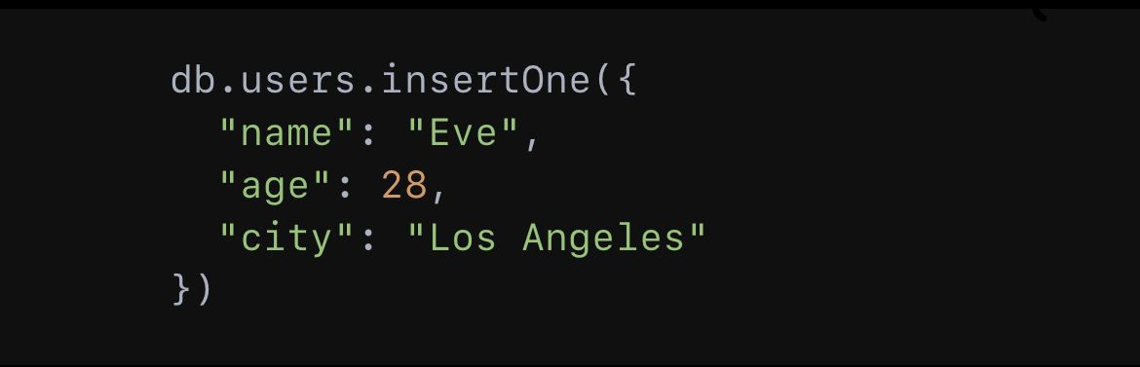

2. *Find*:

- Querying documents in a collection.

Example:

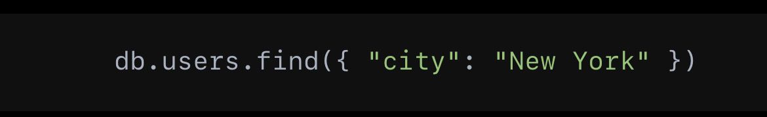

3. *Update*:

- Modifying existing documents.

- Example:

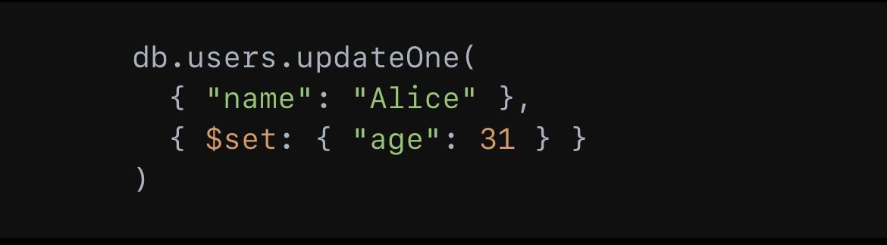

4. *Delete*:

- Removing documents from a collection.

- Example:

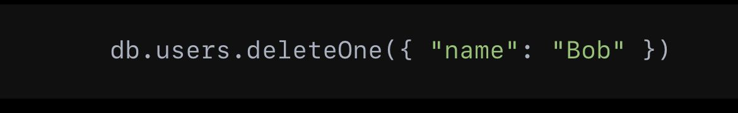

**COLLECTIONS**

Collections A collection is a group of documents.

 If a document is the MongoDB analog of a row in a relational database, then a collection can be thought of as the analog to a table.

**DATABASE**

MongoDB groups collections into databases.

A single instance of MongoDB can host several databases, each grouping together zero or more collections.

A database has its own permissions, and each database is stored in separate files on disk.

 A good rule of thumb is to store all data for a single application in the same database.

**DATATYPE**

Basically each document will be in JSON format which will be as follows. Where each attributes inside can be of multiple data types.

